**Optimisation of Solar Photovoltaic Technologies on a Domestic Property**

Group Number 9

Subsystem 1: Jacob Mitchell Subsystem 2: Connie Hodgson; subsystem 3: xx xx’)

*Note: This is a formal report and should be well-written and organized. Part of the grade will be for professionalism and presentation. (This paragraph should be deleted in your report.)*

# Abstract

An abstract of approximately 200 words describing your problem and the results obtained. Do not write generalities and be specific about your work. An abstract of approximately 200 words describing your problem and the results obtained. Do not write generalities and be specific about your An abstract of approximately 200 words describing your problem and the results obtained. Do not write generalities and be specific about your An abstract of approximately 200 words describing your problem and the results obtained. Do not write generalities and be specific about your An abstract of approximately 200 words describing your problem and the results obtained. Do not write generalities and be specific about your

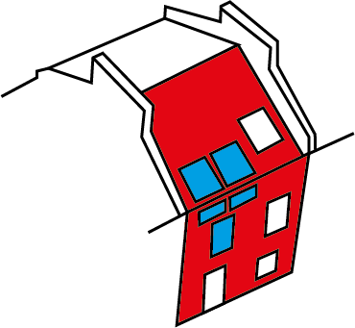

Figure domestic property Subsystem 1 (blue) and Subsystem 2 (red)

# Introduction

Photovoltaic solar technologies provide a potential solution for low carbon energy generation. Conventional solar panels require a lot of space to be cost effective. The optimal use of novel building integrated photovoltaics (BIPVs) could overcome this issue by retrofitting semi-transparent into pre-existing windows in combination with optimised conventional PV panels on the roof and wall façade. The main objective of the system optimisation is to produce enough energy to cover the electricity consumption of the property while keeping installation costs affordable and minimising the number of panels used.

***previous work that has been done by others.***

# Subsystem 1 – Window Integrated Photovoltaics

Subsystem 1 focused on the use of Building Integrated Photovoltaics (BIPVs) which could be implemented in the pre-existing window frames of the domestic property. BIPV technology is fairly new and has the potential to revolutionise the use of solar technology in buildings without sufficient accessible wall and roof space required for traditional PVs. The BIPVs panels came in a range of power ratings, with varying transparencies these can be found in **APPENDIX**.

The main objective of subsystem 1 was to find the best combination of panels in 5 windows belonging to one room that minimises the number of years it takes to achieve a return on investment (ROI) for the installation. The main interests of the subsystem were which windows were most effective and what power rating satisfied the requirements and had and optimum solution.

# Optimisation formulation

2.1.0

2.1.1

2.1.2

2.1.3

2.1.4

2.1.5

2.1.6

2.1.7

2.1.8

2.1.9

2.1.10

2.1.11

2.1.12

2.1.13

2.1.14

**Describe all functions** and **variables**. **Justify this structure** using references and **explain any assumptions**.

# Modelling approach

The variables corresponded to the power ratings (kWh) of the panels installed in windows 1-5. These values are obtained from the material specification sheet provided by manufacturers(1) .

The objective function (equation 3.1.0) calculates the number of years that it takes for a return on investment of the configuration and is the ratio of upfront cost (equation 3.1.5) over the yearly payback (equation 3.1.8).

(equation 3.1.5) was calculated by the sum of the number of panels used for that configuration of windows. Each panel cost £400 (1) with an additional installation cost of £500 per window for installation(2). An value of 0 implied that the window remained unchanged so incurred no costs.

(equation 3.1.8) was calculated by the product of yearly energy generated by the array configuration, (equation 3.1.7) and the feed in tariff (FIT) rate (3). was calculated using the yearly solar irradiance values on both the wall façade and roof area as well as the power ratings of the panels taken from the product specification sheet (1). These were acquired from a PV SOL simulation that took into account the geometry, shading and geographical location of the property.

(equation 3.1.2) states that the number of hours of ‘quality’ light must be greater than 6. The ‘quality’ of light was determined by being greater than standard office lighting conditions of *500 lux* (4). The irradiance values selected for this constraint was an average day in January, obtained from PV SOL. The Light levels in Lux falling on the work area for each hour of the day was calculated. This is calculated by assuming the windows as point sources, with the illuminance of each source taken as a product of irradiance, transparency and panel area. Transparency (, equation 3.1.14) was determined using a linear regression model using transparency and power data from the specification sheet (1). The minimum number of hours required were based on the subjective design requirements determined by communicating with our ‘client’.

(equation 3.1.3) states that cost of this subsystem must be less than £4000**.** This value was taken as a maximum cost due to the subjective design requirements of the project put forward by our ‘client’. This was calculated by the cost function described earlier.

(equation 3.1.4) states that the yearly energy generated by the subsystem must be greater than 100 kWh. This constraint is a subjective baseline. **REWORD**

# Explore the problem space

In order to understand the problem better a full factorial experiment was conducted. For every combination of the , and was plotted against the objective function (figure 1).

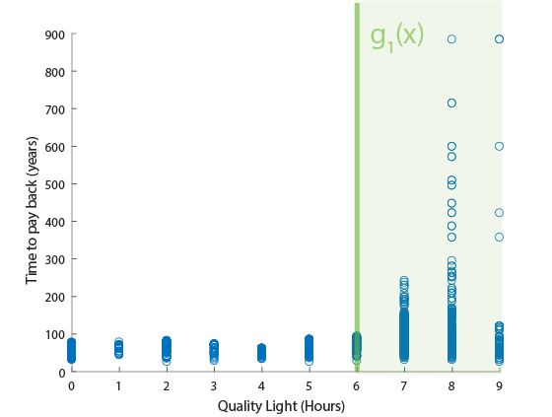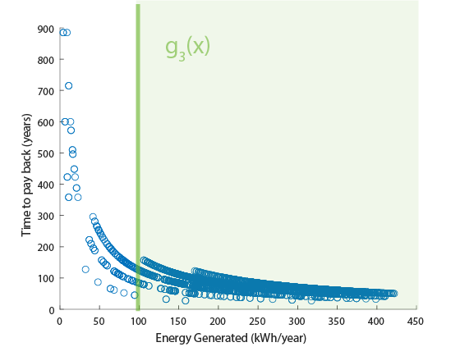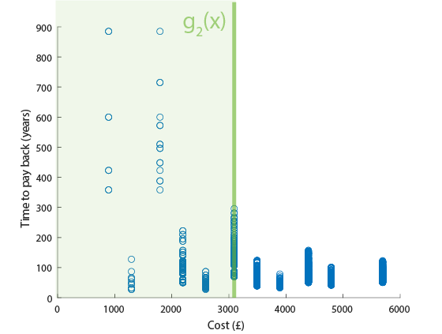

Figure L(x), E(x) and C(x) with constraints from left to right

Upon visual inspection of the range space it was noted that due to the complex and discrete nature of the problem space, no clear gradients were found in light quality and cost. There did seem to be some exponential relationships with energy and the objective function, however the complexity and layers of values implied that it would be difficult to solve with gradient based solutions.

Constraints and appeared active wrt cost and light quality as they appeared to eliminate possible minima from the range space. Constraint seemed inactive wrt Energy production as it did not eliminate any optimum solutions. However, an optimiser would be needed to test this in more detail. Each constraint was removed independently and tested with the Genetic Algorithm (GA) solver. As predicted, removing changed the optimum solution. When was removed the optimisers tended to full power and zero transparency as light requirements were not constricting the model. When was removed, the optimum solution did not change dramatically. As predicted removing had no effect on the solution. Multiple runs and only significant changes of the optimum were used to test for constraint activity. This was because of the stochastic nature of the solver, producing slightly different answers each time. **TEST THIS AGAIN PS solver used because it is more consistent?** Therefore, to simplify the formulations, constraint and can be removed from the formulation.

# Optimisation

Optimise problems can be solved using gradient-based or heuristic optimiser algorithms. Gradient based methods must be continuous, convex and differentiable (5). The initial exploration of the problem space showed that this problem has none of these features. A literature study of similar projects have shown that Genetic Algorithm (GA) and Particle Swarm (PS) optimisers have been shown to be effective at solving similar problems(6).

The optimisers were set up by modelling the discrete variables as continuous and applying the upper and lower bounds of the variables described in equation 3.1.0. For GA, the initial conditions were varied and tested however it was found not to have a significant effect on the solution. The results of each optimiser are shown in Table 1. Figure 2 shows the both the solution panel configurations and the explored range space of each solver. It should be noted at this point that both solvers are stochastic (rely a degree of randomness) so it is unlikely to produce exactly repeatable results.

|  |  |  |  |  |  |  |  |  |  |  |
| --- | --- | --- | --- | --- | --- | --- | --- | --- | --- | --- |
| **Solver** | **Time to solve (s)** | **(kWh**  **/m2)** | **(kWh**  **/m2)** | **(kWh**  **/m2)** | **(kWh**  **/m2)** | **(kWh**  **/m2)** | **Years** | **Cost (£)** | **Energy (kWh)** | **Light (hrs)** |
| Genetic Algorithm | 7.094 | 0 | 0.104 | 0 | 0 | 0.104 | **22.581** | 2600 | 298.3 | 6 |
| Particle Swarm | 0.76804 | 0 | 0.104 | 0 | 0 | 0 | **21.192** | 1300 | 158.92 | 6 |

Table Optimisers and Optimum of GA and PS

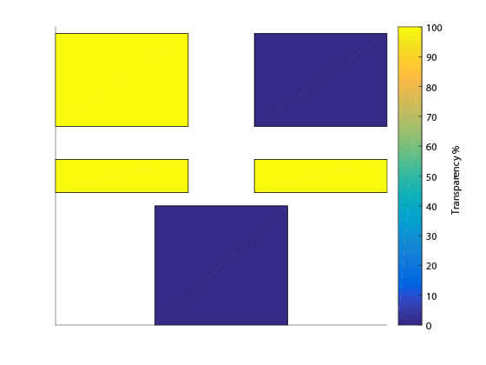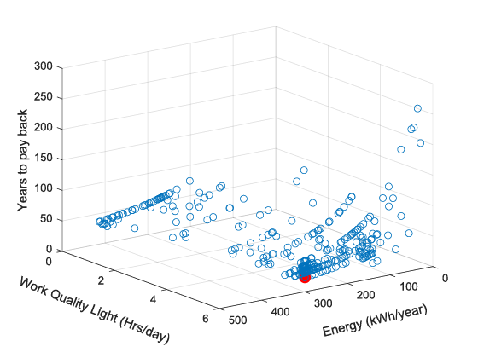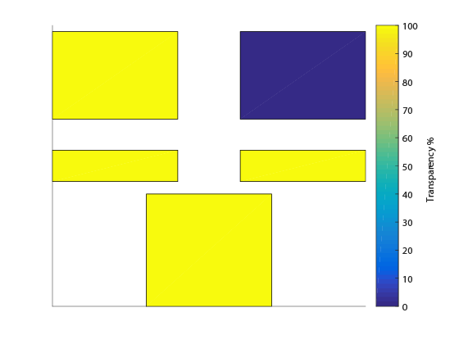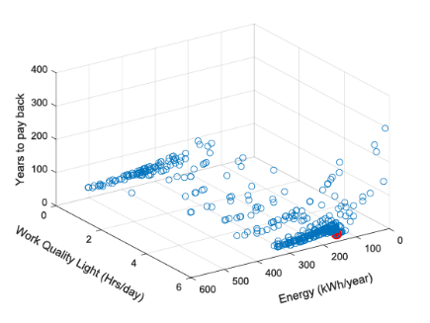

Figure Optimal Panel configuration of GA and PS (left to right) Optimiser explored Range Space (left to right) Solution in red

Post optimal sensitivity analysis was conducted and the results shown in Table 2. This showed that the variables that had the greatest effect on the output function were and . Despite the optimisers provided containing many 0 values. For the sake of the sensitivity analysis the values were set to 0.104 so that the affect of each could be seen.

|  |  |  |  |  |  |
| --- | --- | --- | --- | --- | --- |
| Variable |  |  |  |  |  |
| % Change in with -10% perturbation | 3.0630 | 3.0630 | 0.7277 | 0.7277 | 2.6756 |

Table Post Optimal Sensitivity Analysis

# Discussion

Both Genetic Algorithm (GA) and Particle Swarm (PS) Optimisers were conducted in order to determine the combination of windows that satisfied the required constraints and achieved an optimal number of years for ROI. Both solvers provide acceptable optimal solutions of 22.6 and 21.2 Years respectively. Although both methods are stochastic, it was found that PS was far more consistent and repeatable than GA. In addition, the GA took significantly longer to solve compared to Particle Swarm. Often on first trial the GA no feasible answers were found, leading to even more prolonged run time to repeat the solver.

The biggest challenge of the subsystem was its complexity. It consisted of many complex models that were each based on many assumptions and due to the number of parallel calculations being made, each model had to be simplified. This at times over simplified the entire model, diminishing a level of validity of the overall subsystem.

This study has informed decision making for the retrofit installation of BIPVs in the windows of a room in a domestic property. It can be scaled to other rooms in the house or in fact to other similar buildings.

The model only concentrated on five windows on the property as these were connected to one room, hence making the light calculations simpler. However, in order to scale the model to include all the windows in the house which might have multiple sources of natural light, a more detailed simulation or dataset for light level sensitivity should be used.

**Briefly summarise this subsystem’s optimisation. Discuss which method seemed to work best, and/or discuss the pros and cons of each. Discuss some of the challenges, design implications, and how the analysis could be improved in the future for application in the real world.**

# Subsystem 2 – Wall and Roof Photovoltaic Modules

# Subsystem 2 – Wall and Roof Photovoltaic Modules

# Modelling Approach

# Explore Problem Space

# Modelling Approach

# Optimisation

# Discussion

# System-level optimisation

The system level optimisation took both subsystems into account. First subsystem 1 ran to obtain an optimal solution for the windows. The energy output of this solution was used as an input value to subsystem 2. Subsytem 2 then calculated an optimum solution for the wall and roof, given the energy it needed in order to reach the total energy required to cover the usage of the house. Once both solutions are obtained they combined to find the total number of years to reach a ROI.

# System level formulation

4.1.0

4.1.1

and 4.1.1

and 4.1.1

4.1.2

4.1.3

2.1.2

2.1.3

2.1.4

3.1.**?**

3.1.?

3.1.?

3.1.?

4.1.4

4.1.5

The total amount of energy production for the whole system was selected by looking at the average energy consumption for a property that size and energy performance band (7). The overall cost of the whole system, () was set as less than £10,000 due to this being a subjective design constraint of our ‘client’.

# Results

When the whole system was run, the following results were obtained.

|  |  |  |
| --- | --- | --- |
| Total Energy (kWh) | Total Cost (£) | Total Years |
| 2950 | 8842 | 7.75 |

*Describe the strategy for solving the system-level optimisation problem. Present a new, more precise formulation if needed, with justifications for any models, parameters, and assumptions.*

*Explore the problem space, and then solve the system-level problem. Justify the solution method.*

*Present the results, discuss what they mean, and describe some of the challenges and future work needed for application in the real world.*

# Conclusion

Briefly and quantitatively summarise what was achieved in the study. Was the goal is met, how, and by how much was the system optimised?

Briefly summarize the greatest challenges in system design and optimisation, and summarise key lessons learnt.

# References

References

(1) Polysolar. *PS-M-NX Series panels - Product Specifications for a-Si/μc-Si thin-film glass/glass laminate BIPV glazing units.* Available from: <http://www.polysolar.co.uk/documents/PS-M-NX%20Technical%20Specification%20sheet.pdf> [Accessed 05/12/2018].

(2) Academy Home. *Window Prices.* Available from: <http://www.academyhome.co.uk/windows/how-much-are-window-prices> [Accessed 13/11/2018].

(3) Ofgem. *Feed-In Tariff (FIT) rates.* Available from: <https://www.ofgem.gov.uk/environmental-programmes/fit/fit-tariff-rates> [Accessed 12/11/2018].

(4) National Optical Astronomy Observatory. *Recommended Light Levels.* Available from: <https://www.noao.edu/education/QLTkit/ACTIVITY_Documents/Safety/LightLevels_outdoor+indoor.pdf> [Accessed 12/11/2018].

(5) Askarzadeh A. Optimisation of solar and wind energy systems: a survey. *International Journal of Ambient Energy.* 2017; Available from: <https://www.tandfonline.com/doi/full/10.1080/01430750.2016.1155493> .

(6) Makhloufi S. Comparative study between classical methods and genetic algorithms for sizing remote PV systems. *International Journal of Energy and Environmental Engineering.* 2015; 6 (3): 221-231.

(7) OVO. *How much electricity does a home use?* Available from: <https://www.ovoenergy.com/guides/energy-guides/how-much-electricity-does-a-home-use.html>.

**List citations here in numbered style; [1] … [n]. Refer to all of them in the text using numbers, e.g. [1].**

# Appendix A. Nomenclature

Define all symbols that you use, particularly for the mathematical model development. Make sure you use a consistent nomenclature and set of symbols in subsystems. (It may also be convenient to divide the symbols list

to subsystems.)

|  |  |  |  |
| --- | --- | --- | --- |
| Variables | Definition | Units | Value |
|  | Power value of panel (1-5) | *kW/* | - |
|  | Area of window 1 |  | 1.44 |
|  | Area of window 2 |  | 1.44 |
|  | Area of window 3 |  | 0.5 |
|  | Area of window 4 |  | 0.5 |
|  | Area of window 5 |  | 1.8 |
|  | Area of working space |  | 9 |
|  | Yearly Irradiance value on window 1 |  |  |
|  | Yearly Irradiance value on window 2 |  |  |
|  | Yearly Irradiance value on window 3 |  |  |
|  | Yearly Irradiance value on window 4 |  |  |
|  | Yearly Irradiance value on window 5 |  |  |
| FIT | Feed in tariff | *£/kWh* | 0.386 |
|  | Irradiance values for wall for each hour of the day |  | - |
|  | Irradiance values for roof for each hour of the day |  | - |
|  | Quality of light | *-* | {0,1} |
| lx | Lux value | *lx* | - |
|  | Distance from window 1 to working space | *m* | 0.4 |
|  | Distance from window 2 to working space | *m* | 1.5 |
|  | Distance from window 3 to working space | *m* | 1.5 |
|  | Distance from window 4 to working space | *m* | 2 |
|  | Distance from window 5 to working space | *m* | 2 |
| Imax | Maximum current for a given power rating | *A* | - |
| Vmax | Maximum voltage for a given power rating | *V* | - |
| Xpos | X position of panel | *m* | - |
| Ypos | P position of panel | *m* | - |
| SA | Surface area of panel array |  | - |
| Sfreq | Shading frequency of panel | *%* | - |
| OF | Obstruction factor | *%* | - |
| Irr | Variables of Irradiance values for each module (1-52) |  | - |
| *R* | Variable of resistance value for each module (1-52) | *Ω* | - |
|  |  |  |  |
| Functions | Definition | *Units* | Value |
|  | Window objective function, the number of years until ROI | *Years* | - |
|  | Function that calculates the cost of the array | *£* | - |
|  | Function that calculates the energy output of the window array | *kWh* | - |
|  | Function that calculates the financial payback of the array | *£/Year* | - |
|  | Function that calculates the number of hours of light that qualifies as sufficient to work during the day | *Hours* | - |
| *t(x)* | Function that calculates transparency (Coefficients from linear regression) | *%* | - |
|  |  |  |  |
| *Et()* | Function that calculates yearly energy produced by wall and roof modules |  |  |
| *Cs(SA)* | Cost function for wall and roof panels | *£* | - |
| *e(Rmax,Irr)* | Efficiency function of the panels | *%* | - |
| *Ps(Cs)* | Payback function for yearly FIT payback | *£* | - |
| *T(Irr,R)* | Time function for payback on ROI for roof and wall panels | *Years* | - |

Note:

1. Upper limit: 8 pages for groups of 2 members (11 pages for the group of 3), excluding References and Appendix of Nomenclature.

2. Except for ‘Appendix A. Nomenclature’, no other Appendices are accepted.